

Module : DOC 311 Academic Skills for Higher Education
Module Leader : Ms. Antoinette Hettiaratchy
Assessment type : Group Coursework
Group ID : J_C1
Topic : The sustainability of electric cars
Student details :

Student ID | Name
20221804 | Muhammed Saad Mazhar
20221803 | Dilina Chathuraka Perera
20221802 | Rafeek Mohammed Alfar
20221798 | Chadithya Dinuwan Udayantha
20222336 | Mohamed Zabrin Mohamed Juzail
20222330 | Akash Sathiyanathan

Executive Summary

This report aims to assess the sustainability of electric cars by examining their environmental, social, and economic impacts, as well as technological developments, policy frameworks, and challenges and opportunities for sustainability.
The report finds that electric cars have lower carbon emissions and a smaller environmental footprint compared to fossil-fuel cars, although the sustainability benefits depend on the sources of electricity used for charging. Electric cars also have the potential to create jobs and stimulate economic growth, but their cost and accessibility may pose challenges for social sustainability.
Advances in battery technology, charging infrastructure, and integration with renewable energy sources provide opportunities for technological sustainability, but these developments also require supportive policy and regulatory frameworks. Government incentives and regulations can help overcome barriers to adoption and promote the sustainable transition to electric cars.
The report recommends that policymakers, industry stakeholders, and consumers collaborate to address the challenges and opportunities for sustainable electric transportation. Strategies such as investing in renewable energy, developing innovative business models, and promoting public awareness and education can contribute to the sustainable adoption of electric cars.

Acknowledgement

We would like to express our gratitude to everyone who has contributed to the successful completion of this report. Firstly, we would like to thank our teachers for their guidance and support throughout the research and writing process. Their constructive feedback and insightful suggestions have been invaluable in shaping this report.
We would also like to extend our appreciation to our seniors who generously shared their time and provided us with the necessary information to conduct this study. Their willingness to participate and their openness in sharing their experiences and insights were instrumental in the development of this report.
Furthermore, we would like to thank our families and friends for their unwavering support, encouragement, and understanding throughout this challenging process.
Finally, we would like to express our appreciation to all the authors of the relevant literature and resources that have contributed to the development of this report. Their knowledge and expertise have been invaluable in guiding my research and writing.
Once again, we express our sincere appreciation to everyone who has contributed to the completion of this report.
Table of Contents
Executive Summary 2
Acknowledgement 3
1. What does “Sustainability of electric cars” mean? 5
2. Environmental Impact of Electric Cars 6
2.1. Carbon emissions from electric cars 6
2.2. Comparison with fossil-fuel cars 7
2.3. Life cycle assessment of electric cars 7
2.4. Environmental benefits of electric cars 7
3. Social and economic sustainability of electric cars 8
4. Advantages & Dis-advantages 9
4.1. Advantages 9
4.2. Dis-Advantages 10
5. Conclusion 11
6. Recommendations 12
7. References 13
8. Appendices 15

What does “Sustainability of electric cars” mean?

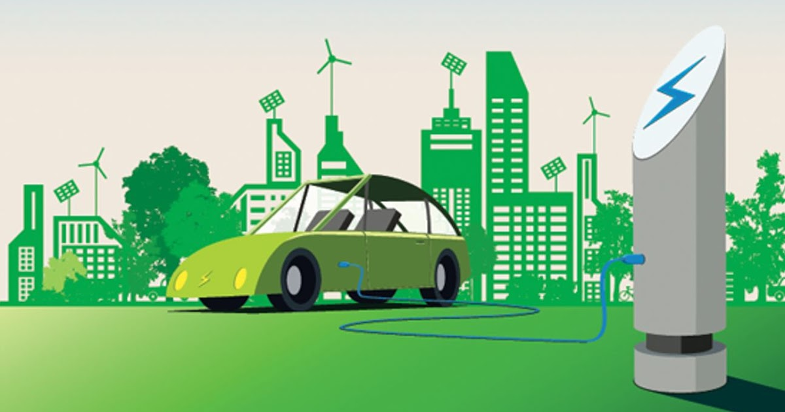
Figure 1 - Sustainability of electric cars
The sustainability of electric cars refers to their ability to reduce carbon emissions, improve energy efficiency, and promote the sustainable use of natural resources, as well as their social and economic impacts. This topic involves assessing the environmental benefits and impacts of electric cars, examining the social and economic implications of their adoption, analyzing the technological developments and outlook for electric car technology, and exploring policy and regulatory frameworks that can promote sustainable transportation. Understanding the sustainability of electric cars is essential for developing strategies to promote the transition to sustainable transportation and mitigate the impact of transportation on the environment and society.

Environmental Impact of Electric Cars

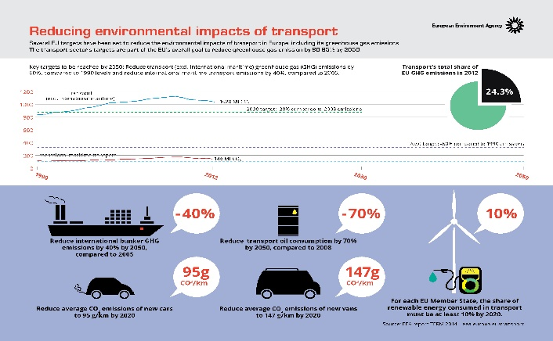
The sustainability of electric cars has significant environmental implications. Electric cars can reduce greenhouse gas emissions, improve air quality, and promote the sustainable use of natural resources. However, their environmental impact also depends on the sources of electricity used for charging, the manufacturing process of batteries, and their disposal. Thus, the sustainable adoption of electric cars requires a comprehensive approach that considers their full life cycle impacts, from raw material extraction to end-of-life disposal. Strategies such as investing in renewable energy, developing sustainable supply chains for batteries, and promoting efficient recycling and reuse of electric car components can contribute to the environmental sustainability of electric cars.
Figure 2 - Economic Impact
This Photo by Unknown Author is licensed under CC BY
Here are a few impacts of electric cars :
- Carbon emissions from electric cars
- Comparison with fossil-fuel cars
- Life cycle assessment of electric cars
- Environmental benefits of electric cars

Carbon emissions from electric cars

Electric cars are considered more environmentally friendly than conventional gasoline or diesel-powered cars, as they produce fewer carbon emissions. The carbon emissions of electric cars depend on the source of electricity used to charge them. If the electricity comes from renewable sources such as solar or wind power, the emissions can be virtually zero. Even when using electricity from fossil fuel power plants, electric cars emit fewer greenhouse gases than their conventional counterparts.

Comparison with fossil-fuel cars

Compared to fossil fuel-powered cars, electric cars have several advantages in terms of environmental impact. In addition to emitting fewer greenhouse gases and air pollutants, electric cars produce less noise pollution and are generally more energy-efficient. However, electric cars can have higher production costs and limited driving ranges compared to conventional cars, which can impact their adoption.

Life cycle assessment of electric cars

A life cycle assessment (LCA) is a comprehensive analysis of the environmental impacts of a product or process over its entire life cycle. LCAs of electric cars consider the environmental impacts of battery production, electricity generation, and end-of-life disposal. The results of these assessments can help identify areas where improvements can be made to reduce the environmental impact of electric cars.

Environmental benefits of electric cars

The environmental benefits of electric cars are numerous. In addition to producing fewer emissions and pollutants than conventional cars, electric cars can also reduce dependence on fossil fuels, improve air quality, and promote the use of renewable energy sources. Electric cars can also be more energy-efficient than gasoline-powered cars, which can save on fuel costs and reduce overall energy consumption. Additionally, as renewable energy sources become more widespread, the environmental benefits of electric cars will increase.

Social and economic sustainability of electric cars

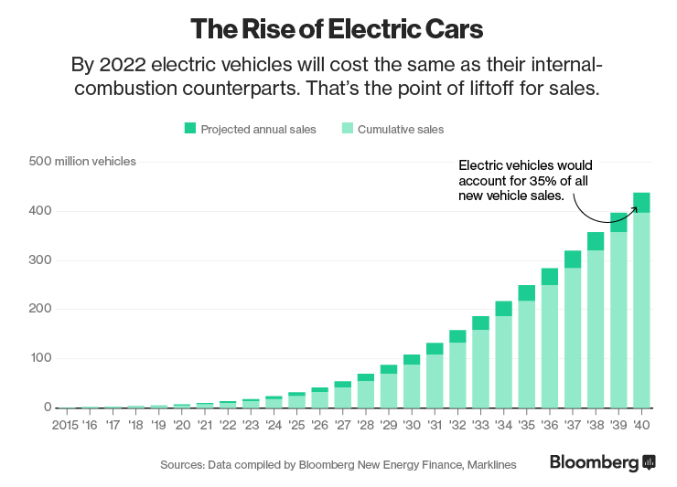
Electric cars offer significant economic benefits, such as job creation, innovation and reduced dependence on foreign oil. They also provide significant social benefits, including improved air quality and reduced health issues caused by pollution. The adoption of electric cars can lead to job creation in areas such as battery manufacturing, charging infrastructure installation and maintenance, and electric vehicle production. However, affordability, accessibility, and equity challenges need to be addressed to make electric cars more accessible to all. Low- and middle-income households may find electric cars unaffordable due to their higher upfront cost compared to conventional vehicles, and access to charging infrastructure and electric cars may be limited in certain regions or communities. Policymakers and industry leaders should work to address these challenges and ensure that the benefits of electric cars are accessible to all.
Figure 3 – Social & Economic stability of electric cars

Advantages & Dis-advantages

Advantages
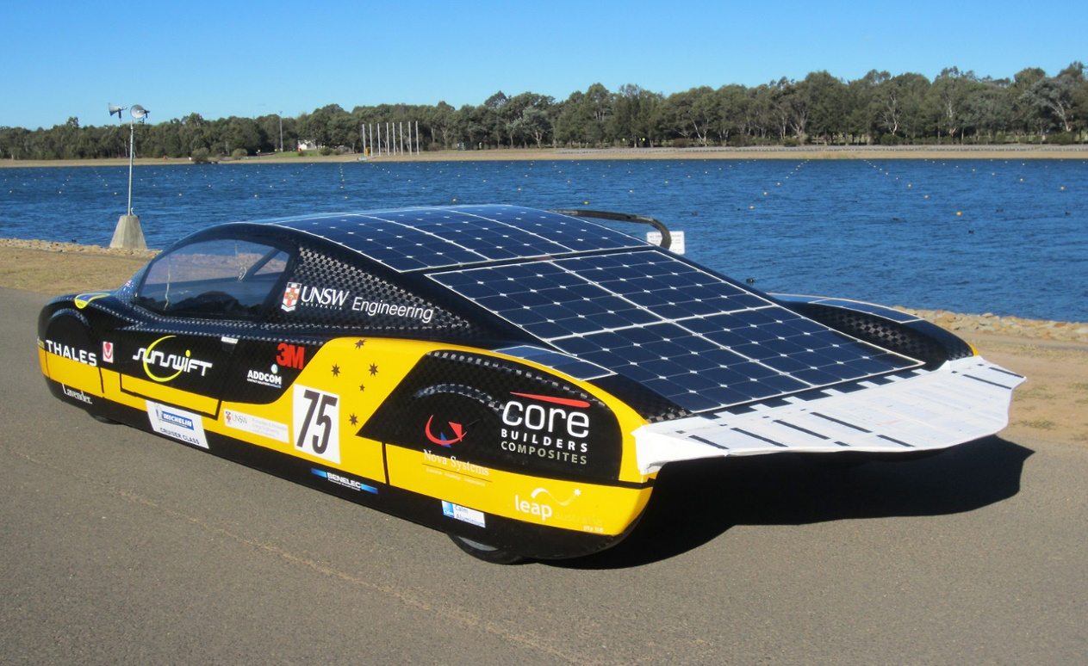
Figure 4 - Advantages of electric cars

Reduced environmental impact:
Electric cars produce no tailpipe emissions, reducing the amount of harmful pollutants released into the air. This leads to improved air quality and reduced greenhouse gas emissions, making them more environmentally friendly compared to gasoline-powered cars.

Lower operating costs:
Electric cars have lower operating costs compared to gasoline-powered cars. Electric cars require less maintenance since they have fewer moving parts, and the cost of charging an electric car is typically lower than the cost of gasoline.

Quiet and smooth driving experience:
Electric cars are quieter and provide a smoother driving experience compared to gasoline-powered cars.

Dis-Advantages
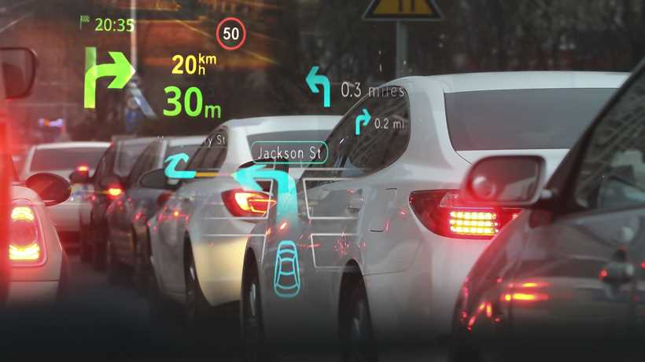
Figure 5 - Disadvantages of electric cars
Limited driving range:
The driving range of electric cars is limited, and they need to be recharged after a certain distance. This makes them less suitable for long trips, and the availability of charging infrastructure is still limited in some regions.

Higher upfront cost:
Electric cars are typically more expensive than gasoline-powered cars, making them less accessible to some consumers.

Longer charging time:
Charging an electric car takes longer than filling up a gasoline-powered car with fuel. This can be inconvenient for drivers who are used to quick refueling stops.

Conclusion

In conclusion, electric cars offer a sustainable solution to the environmental and social challenges posed by conventional gasoline-powered cars. The adoption of electric cars can lead to reduced greenhouse gas emissions, improved air quality, job creation, and technological innovation. However, challenges such as limited driving range, higher upfront costs, and limited charging infrastructure need to be addressed to make electric cars more accessible to all. Despite these challenges, the benefits of electric cars outweigh the drawbacks, and the electric vehicle industry is poised for growth and innovation. Policymakers and industry leaders must work together to address these challenges and ensure that the benefits of electric cars are accessible to all, promoting a sustainable future for transportation.

Recommendations

Based on the findings of this report, the following recommendations are made:
- Increase investment in charging infrastructure: To promote the adoption of electric cars, there needs to be an increase in investment in charging infrastructure, especially in urban areas, to ensure that electric cars can be charged conveniently.
- Develop policies to make electric cars more affordable: Policymakers should consider implementing incentives, such as tax credits and rebates, to make electric cars more affordable for consumers.
- Promote research and development: Continued research and development are needed to improve the performance and affordability of electric cars, as well as the sustainability of the materials used in their production.
- Increase public awareness: There is a need to increase public awareness about the environmental and social benefits of electric cars, as well as their availability and accessibility.
- Address equity concerns: Policymakers and industry leaders should work to address equity concerns related to electric cars by ensuring that the benefits of the technology are accessible to all communities and income levels.
By implementing these recommendations, we can promote the sustainable adoption of electric cars and help to mitigate the environmental and social impacts of transportation.

References

United States Department of Energy. (n.d.). Sustainability of Electric Vehicles. Retrieved from
https://www.energy.gov/eere/electricvehicles/sustainability-electric-vehicles
[Accessed 16 Mar. 2023]

International Energy Agency. (n.d.). Electric Vehicles. Retrieved from https://www.iea.org/topics/electric-vehicles
[Accessed 16 Mar. 2023]
National Renewable Energy Laboratory. (n.d.). Electric Vehicles. Retrieved from https://www.nrel.gov/transportation/electric-vehicles.html
[Accessed 16 Mar. 2023]
Union of Concerned Scientists. (n.d.). Electric Cars: Environmental Impact. Retrieved from https://www.ucsusa.org/resources/electric-cars-environmental-impact
[Accessed 16 Mar. 2023]
Environmental Defense Fund. (n.d.). Electric Vehicles. Retrieved from https://www.edf.org/transportation/electric-vehicles
[Accessed 16 Mar. 2023]
Car and Driver. (2021). Pros and Cons of Electric Cars. Retrieved from https://www.caranddriver.com/research/a32879456/pros-and-cons-electric-cars/
[Accessed 16 Mar. 2023]
The Welding Institute (TWI). (n.d.). What is an EV? Frequently Asked Questions. Available at: https://www.twi-global.com/technical-knowledge/faqs/what-is-an-ev#:~:text=EVs%20are%20vehicles%20that%20are,fuels%20(petrol%20or%20diese
[Accessed 16 Mar. 2023]
Electric car. (2022). In Encyclopædia Britannica. Available at: https://www.britannica.com/technology/electric-car
[Accessed 16 Mar. 2023].
EDF Energy. (n.d.). Electric Cars and the Environment. Energywise. Available at: https://www.edfenergy.com/energywise/electric-cars-and-environment
[Accessed 16 Mar. 2023].
Renault Group. (2019, September 4). The energy efficiency of an electric car motor. News. Available at: https://www.renaultgroup.com/en/news-on-air/news/the-energy-efficiency-of-an-electric-car-motor/
[Accessed 16 Mar. 2023].
Larminie, J., & Lowry, J. (2019). Electric Vehicle Technology Explained (3rd ed.). Elsevier. Available at: https://doi.org/10.1016/B978-0-12-815801-2.00006-X
[Accessed 16 Mar. 2023].
Alternative Fuels Data Center (AFDC). (n.d.). Benefits of Electric Vehicles. Available at: https://afdc.energy.gov/fuels/electricity_benefits.html#:~:text=and%20conventional%20vehicles.-,Fuel%20Economy,than%20that%20of%20conventional%20vehicles
[Accessed 16 Mar. 2023].
Ramos, S. (2019, January 29). Electric Cars: Are They Truly Sustainable? BBVA OpenMind. Available at: https://www.bbvaopenmind.com/en/technology/innovation/electric-cars-truly-sustainable/ [Accessed 16 Mar. 2023].

Appendices


The Guardian with Tesla CEO Elon Musk in which he discussed various topics related to electric cars and Tesla's future plans.
In the interview, Musk talked about the importance of accelerating the transition to sustainable energy, the challenges of scaling up production, and the need for increased investment in renewable energy infrastructure. He also discussed Tesla's plans for expanding its product line, including the development of self-driving technology and the release of new electric vehicle models. This interview can is available at https://youtu.be/KSkDNE0_CdY

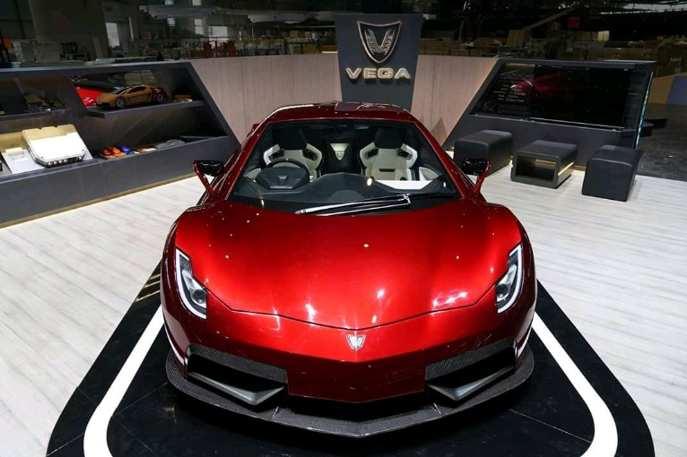
Vega is an electric car that was designed and built in Sri Lanka. The car was first introduced in 2017 and was created by CodeGen, a software development company based in Sri Lanka. The Vega is a four-seater electric car that features a range of up to 240 km on a single charge and can reach a top speed of 90 km/h.
The Vega car is powered by a 13-kWh lithium-ion battery pack and has an AC motor with a peak output of 25 kW. The car's battery can be charged using a standard domestic power outlet or a fast charger, which can charge the battery up to 80% in just one hour.
One of the unique features of the Vega car is its modular design, which allows for easy customization and repair. The car's body is made of lightweight materials, including aluminum and carbon fiber, which makes it more energy-efficient and eco-friendly. The Vega also has advanced safety features, including an ABS system and a front and side impact protection system.
The development of the Vega car is a significant achievement for Sri Lanka, as it marks the first time a car has been designed and built entirely within the country. The car has the potential to contribute significantly to the country's economy, by creating new jobs in the automotive industry and reducing Sri Lanka's dependence on imported cars. Available at https://youtu.be/yG8KPeX9x2k

